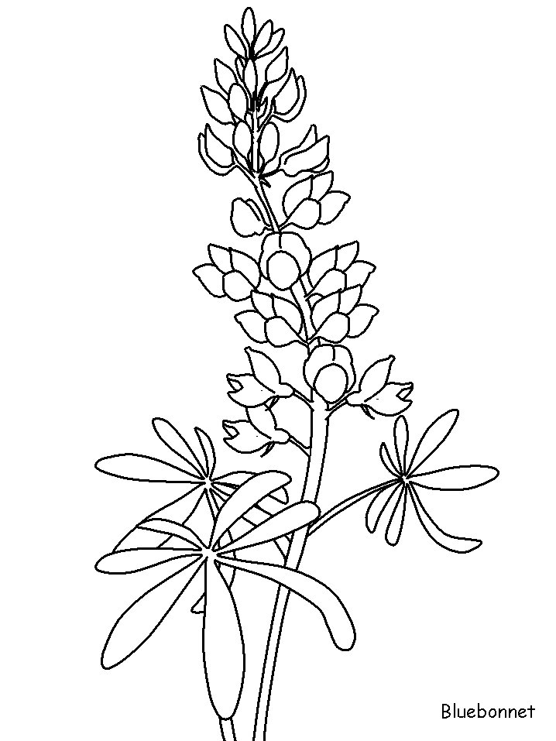Chappell

[Type a quote from the document or the summary of an interesting point. You can position the text box anywhere in the document. Use the Drawing Tools tab to change the formatting of the pull quote text box.]

Hill

Bluebonnet

Festival

Chappell Hill Historical Society Museum

9220 Poplar Street

Chappell Hill, Texas 77426