**[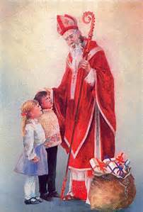](http://www.bing.com/images/search?q=Polish+Santa+Claus&view=detailv2&&id=2044422BBBAD69B39E17A174741613AA949F94FC&selectedIndex=0&ccid=lD/%2bSMmo&simid=607990769899080043&thid=OIP.M943ffe48c9a87a1cbc1d084eb467a698H0)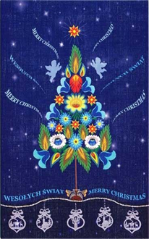15th Annual**

**“Polskie Kolędy”**

**Chappell Hill, Texas**

**December 31, 2022**

**12:30 p.m. Meet at St. Stanislaus Catholic Church “Kościół Katolicki sw. Stanisława”**

9175 FM 1371, Chappell Hill, TX 77426

**Rev. Thaddeusz Tabak, Pastor**

*Pernik (Gingerbread)*

**1:00 p.m. Depart for Albin & Janey Mikołajczyk family**

8263 Whiddon Road, Chappell Hill, Texas 77426

**1:15 p.m. Mikołajczyk home**

**2:30 p.m. Depart for Betsy and John Striegler family**

4900 Sandy Lane, Chappell Hill, Texas 77426

**2:45 p.m. Betsy and John Striegler’s home and co-hosted by the Peterson and Hoffart families**

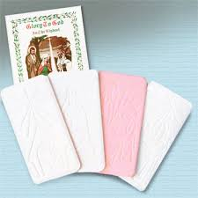**4:00 p.m. Depart for Chappell Hill Museum**

9220 Poplar St.

Chappell Hill, Texas 77426

979-836-6033

**4:15 p.m. Chappell Hill Museum**

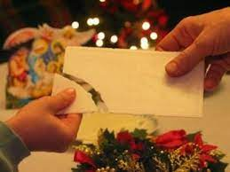**5:30 p.m. Depart for St. Stanislaus Catholic Church for Mass**

St. Stanislaus Catholic Church “Kościół Katolicki sw. Stanisława”

9175 FM 1371

Chappell Hill, TX 77426

**6:00 p.m. Mass at St. Stanislaus Catholic Church**

**7:15 p.m. Program adjourn**

Polish Muscians: Brian Marshall, Jakub Marshall, Michael Marshall, Leonard Kasowski, Johnny Kubecka, Ronnie Kasowski, Jake Kasowski, Frank Motley, CJ Jozwiak, Charlie Brossman, Fabian Jerierski, James Mazurkiewicz, Brian Wisnoski, Robert Herridge

*Wesołych Świąt Bożego Narodzenia i Szczęśliwego Nowego Roku!*

*Merry Christmas and Happy New Year!*

